Lab 01: Introduction to Cabbage Chemistry and Plant-derived Acid/Base Indicators

In this lab we will be exploring the acid/base properties of commercially available solutions using a chemical indicator extracted from red cabbage. We will discuss the nature of solutions and the applicability of chemical indicators for approximating the pH of a solution.

A solution is a mixture of a soluble chemical dissolved in water. Think about the difference between saltwater and tap water. The salt in the saltwater has dissolved and the solution looks clear, but the salt is still there and will taste salty if you taste it. Because solutions are made with water, which is made of hydrogen and water, the hydrogen in the water can make a solution into an acid or a base (see Figure 1).

Figure 1: This picture shows the pH scale and common reagents that fall into the various acidic and basic categories. There is a good chance that you have a lot of these chemicals around your house!
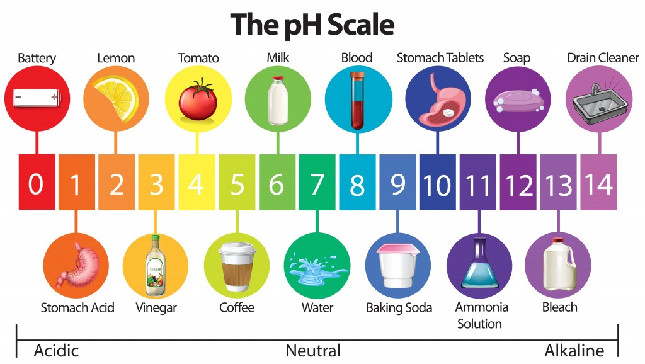
You might think about an acid as something that an evil villain uses to trap a superhero, but actually some very common household solutions are acids. Acids are solutions that will donate hydrogen ions in a solution, and usually taste sour. Some common acids are citrus fruit juices and household vinegar. Bases are solutions that accept hydrogen ions in solution, and usually feel slippery. Bases have many practical uses. "Antacids" like TUMS or Rolaids are used to reduce the acidity in your stomach. Other bases make useful household cleaning products.

How do you tell if something is an acid or a base? You use a chemical called an indicator, which changes in color depending on whether a solution is acidic or basic. (Specifically, an indicator works by responding to the levels of hydrogen ions in a solution.) There are many different types of indicators, some are liquids, and some are concentrated on little strips of "litmus" paper. Indicators can be extracted from many different sources, including the pigment of many plants.

Red cabbage contains an indicator pigment molecule called flavin, which is one type of molecule called an anthocyanin. This water-soluble pigment is also found in apple skin, red onion skin, plums, poppies, blueberries, cornflowers, and grapes. Very acidic solutions will turn anthocyanin a red color. Neutral solutions result in a purplish color. Basic solutions make a greenish-yellow or yellow color (see Figure 2).

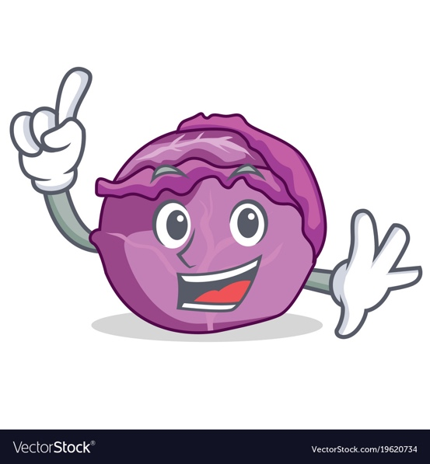
Figure 2: This picture shows some of the different colors that red cabbage juice can become. From left to right, the solutions shown range from very acidic (red) to very basic (yellow). Because red cabbage has this indicator pigment, it is possible to determine the pH of a solution based on the color it turns the red cabbage juice. The pH of a solution is a numerical measure of how basic or acidic it is. A solution with a pH between 5 and 7 is neutral, 8 or higher is a base, and 4 or lower is an acid.
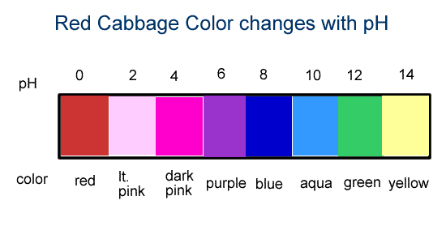

What will you need and how will you do it?

- Grate a small red cabbage and place the pieces into a large bowl or pot.
- Pour boiling water into the bowl to just cover the cabbage. Use caution when handling the boiling water.
- Leave the cabbage mixture steeping, stirring occasionally, until the liquid is room temperature. This may take at least half an hour. The liquid should be reddish purple in color
- Place a strainer over a second large bowl or pot and pour the mixture through the strainer to remove the cabbage pulp. Press down on the pulp in the strainer, such as by using a large spoon, to squeeze liquid out of the pulp.
- In the bowl, you should now have a clear liquid that will either be purple or blue in color. (It should look darker after the pulp is removed.) This will be your indicator solution.
- Set aside your indicator solution. You will use it as your “stock” solution for your experiments.
- Next you will test various household solutions with your indicator. Use a separate Styrofoam cup for each solution you want to test because you do not want to mix chemicals that do not go well together.
- Fill about half of the cup with your cabbage indicator solution. You can use less indicator solution for each cup if you do not have a lot of indicator solution.
- Add drops of a liquid you want to test until you see the solution change in color. Gently swirl the cup as you add the drops, being careful not to spill the solution.
- Record the pH and a description of each solution in a data table in your lab notebook.
- Analyze your results. How does the pH of the different household items you tested compare to each other? Are you surprised by any of your results?
- Prepare your formal lab report using the template provided.
Chemical | Qualitative Color Change | Estimated pH of Chemical | Acidic or Basic?
Lemon Juice
White Vinegar
Soda Pop
Tap Water
Toothpaste*
Baking Soda*
Household Bleach
* Indicate compounds that have been dissolved in water for ease of experimentation.

